**SHREE BOYS HOSTEL**

**Rector Login**

**Student Login**

**Rules and Regulation**

**About Us**

**Home**

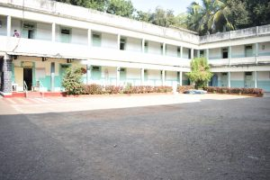



**Home**

**Logout**

**Documents**

**Admission**

|  |  |  |  |
| --- | --- | --- | --- |
| Admission Id | Name | Room No | Action |
| 1 | Shreyas | 1 | Del  Edit  View |

**Educational Information**

**Address Details**

**Reports**

Save

Zip Code

Country

State

City

Area/Landmarks

House No/Name

Current year

Course Name

College Name

**Personal Information**

Guardian Email Id

Guardian Mobile No

Guardian Name

Caste

Blood Group

Date of Birth

Email Id

Mobile No

Name

Name